The map of 1749 of the "Bohemian" village Hussinetz
near Strehlen in Silesia
from dr. Hans-Dieter Langer

Introduction

In 1749, at the instigation of Frederick the Great, the village of Hussinetz was founded on an former outskirts of Strehlen by a contract of sale with the county seat of Bohemian emigrants. It was renamed Friedrichstein in the time of the 3rd Reich and has been called Gesiniec since 1945. At that time the king made by concession at the insistence of the emigrants for the time highly unusual social and cultural concessions¹⁾. These unique privileges of the king as well as donations from Prussia, Holland and Switzerland ²⁾ made it possible to acquire two outworks and the southern part of Strehlener Altstadt. Other historical circumstances meant that Hussinetz/Strehlen today is a European cultural island with German, Czech and Polish national character. In addition, according to Silesian history, on the one hand many other nations have left their mark, and on the other hand, numerous displaced persons and also voluntary emigrants have traveled all over the world from here. There is already an extensive international literature in many disciplines, but also numerous memoranda of visitors, displaced persons and Aussiedlern.

The website fotopolska.eu turns out to be increasingly a worthwhile find place for other documents in the history of Silesia. For example, in the section dolnoslaskie.fotopolska.eu/Gesiniec/b46940 (with the entry of today's Polish place name Gesiniec, or Friedrichstein or Hussinetz) under "Mapy i plany" an old site plan of the village Hussinetz appeared, see Figure 1. It is dated in the more recent accompanying text in the year 1749. The Polish signature reads: "XVIII wieczny plan zabudowy i kolonizacji wsi" (free translation: construction and colonization plan of the village from the 18th century). The lettering in the drawing, however, are by no means attributable to this time, but probably date from the early 20th century. Also, there are doubts about the contemporary way of presenting when comparing with other maps. However, even if it was at best an original artwork that had been reshaped in a recent work or used in a logically modified but consistent copy to make the present plan, it would be very relevant to Hussinetz research. Various inquiries and attempts to get more in Poland about the source too unfortunately failed so far.
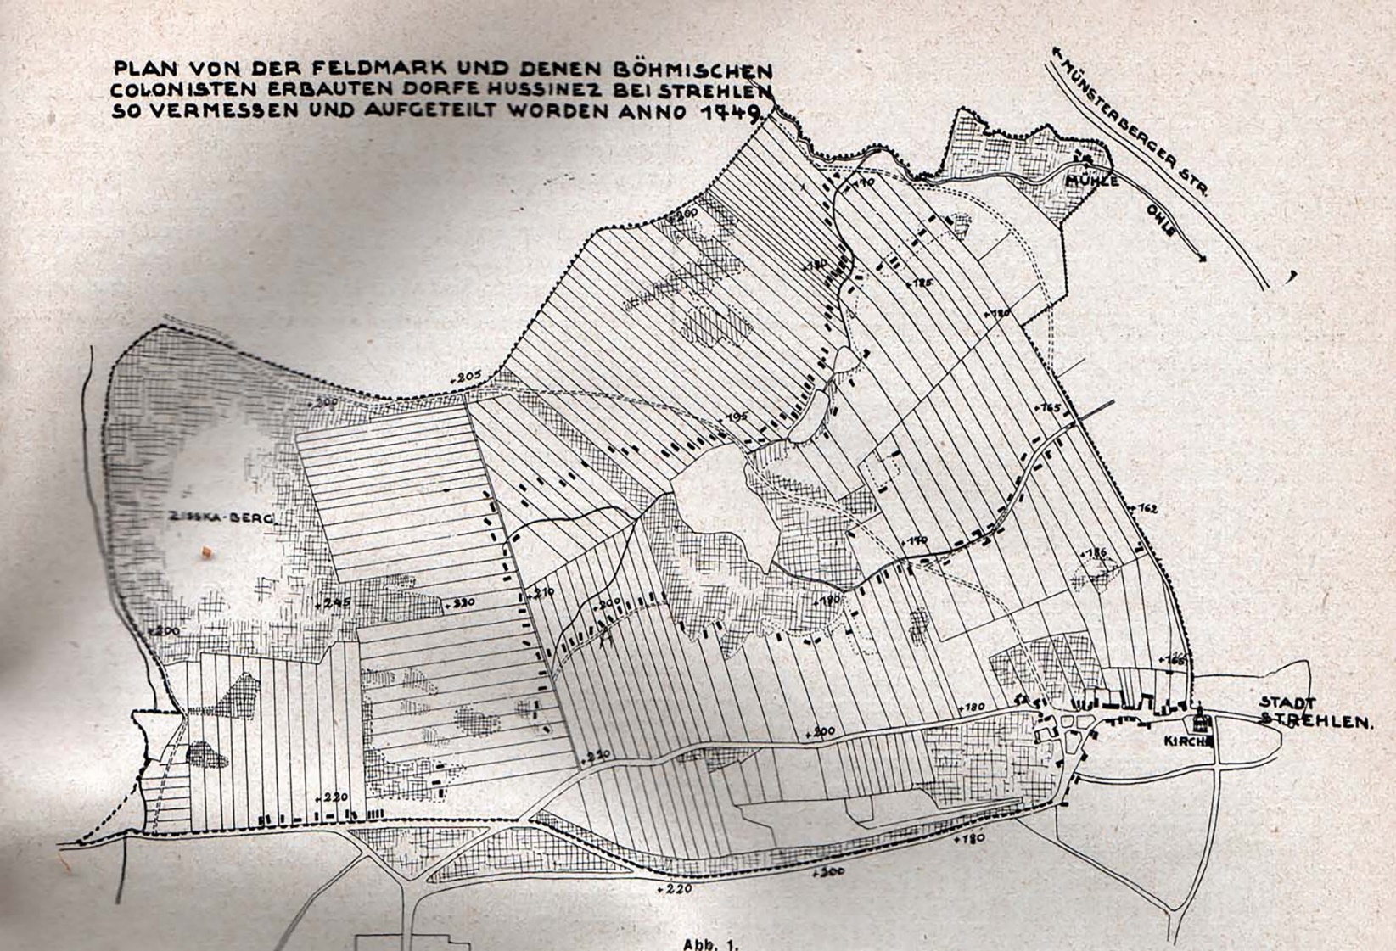

Figure 1: Map of Hussinetz / Silesia, which - whatever happened - represents the situation in the founding year 1749
On the other hand, it is known that the Polish increasingly open to the public use of German archives and more and more Polish citizens are bringing corresponding documents from private property onto the market. The memory literature is well known full of evidence of corresponding losses in the turmoil of expulsion after World War II.

From the contract of sale of April 30, 1749, between the city of Strehlen and the Evangelically Reformed Bohemian Community, we quote ²⁾: "In a particularly to be included Riss, and to be made on it Charter in the future to be expounded in the tradition". On 13.12.1749, the leader of the village founders, their preacher Wenzeslaus Blanitzky, wrote in Switzerland ³⁾: "We record a card from Hussinetz." It also says ⁴⁾: "The church (Hussinetz) wanted to be one of the drawing to make copperplate engraving to show the Dutch and the Swiss that the money really was blessing, and - at the same time, to liquidate new funds. " Finally, it is clear from the concession that a card is to be made. Thus, we have to determine by 1750 at the latest that a site plan was actually created at that time, especially on the basis of which then a meticulous division of land among the numerous settlers took place, which of course presupposed a fairly accurate survey.

A detailed analysis of the circumstances surrounding the founding and subsequent structural development of the village of Hussinetz therefore leads to the realization that there is - whatever the case - a genuine historical treasure which requires a thorough scientific evaluation. This article is also intended to stimulate further research into the research and documentation of the European cultural island of Hussinetz/Strehlen in Silesia and to revive the preservation of monuments.

1. Historical Maps: Appreciation and Authenticity

1.1 Comparison Considerations

First of all, it should be noted that in the Hussinetz case of 1749 it is evidently a site plan in the surveying sense, because it is mainly about the corridor boundaries. In the late Middle Ages and the early modern period, views drawn or painted first came into fashion, especially under the aspect of fortress construction. A typical example of this are the works of Wilhelm Dilich (1571-1650), who was active in Saxony from 1625 to 1650 throughout Saxony. Although there are some equally old site plans in Germany, for example, the oldest "measured" site plan of the city of Dresden with the fortifications on the Zwinger dates back to 1750 ⁵⁾. To Chemnitz, to name another Saxon example, the Trenckmann plan applies the year 1761 as the oldest site plan ⁶⁾, but it is not exactly an exact measurement underlies him. In the late 18th century, more and more "measurements" of men's goods took place. In the end, they culminated in the very advanced Saxons in the mile sheets produced between 1780 and 1806 by nationwide triangulation. In Prussia, astronomical methods simultaneously produced similar map works, e.g. the "Schroettersche Landesaufnahme" (1796 to 1802). Also militarily motivated, namely in the course of the Silesian Wars, Frederick the Great had ordered much earlier regional mapping with increased accuracy, including "War of Silesia", recorded by Wrede 1746-1753, and "Silesia left the Oder ", Recorded by regulator 1763-1770 (terrain between Ohlau and Strehlen) ⁷⁾. It can therefore be assumed that the engineer Bruckampf ⁸⁾, who was commissioned by the king in 1749 to survey the Strehlen Vorwerke, already had experience in precise surveying. Of course, one wonders today how exactly the results actually came about at the time. As a result of the current georeferencing of historical maps, e.g. The Saxon State and University Library or the University of Greifswald, one has to accept detected positional deviations of 10 to 100 m as a matter of course. Not to mention the widespread lack of early village maps in Germany, such high local inaccuracies of surveying could not even be tolerated for some reason in the case of Hussinetz. It should only be remembered that many of the approximately 190 field parcels - and this was the peasant new settlers in the year 1749 crucially - were less than 50 m wide, what you can still understand today in the parcel inventory.

A calibration of the present "map of Hussinetz 1749" is indeed out, but worth a once in a more qualitative comparison with the Messtischblatt Strehlen / 3078 of the Prussian State of 1884, see Figure 2, or with today's conditions using maps.google.de , see below. When comparing the plans to 1749 and 1884, namely, an important authenticity indicator, namely that the former is not eingenordet, which prevailed in the maps only in the course of the 19th century. Nevertheless, the two historical templates in Figure 3 were superimposed in order to compare even better. Of course, the result has little to do with georeferencing, because it was copiously rotated, scaled, shifted and distorted with the aid of the Adobe Photoshop Elements 10 image editing program ⁹⁾. However, it is easy to see the similarities of the basic settlement structure, which incidentally still exists today - eg. according to maps.google.de Gesiniec - is largely preserved. On the one hand the contour lines in the measuring table sheet and on the other hand the parcel boundaries to Hussinetz 1749, which are not contained in the other plan, are dominant. Thus, a first advantage of the much older site plan already stands out: These are the best prerequisites for the desired conservation area in connection with the project "European Cultural Island Hussinetz/Strehlen", which the author is particularly interested in ¹⁰⁾.

1.2 Is the Hussinetzer site plan authentic?

Mountains / valleys / ponds (topology of the landscape)

Below, where existing, historic references are made, which should underline the content authenticity of this Hussinetz card to 1749.In addition to the settlement areas with corridor boundaries and buildings, the two larger areas on the left edge and in the middle of the plan stand out: These are a prominent, historically important mountain and the public-important, central Tallaue of the village. But the fact that 24 height points are indicated (obviously later, because in the 18th century height surveys were by no means common, and only roughly compared to the height data in the plan to 1884), shows at least the remarkable granitvulkanisch certain scenic relief of the village Hussinetz in the northern foothills of the Strehlener Berge ¹¹⁾.

The goat mountain

From a letter of 17.6.1748 in the context of the preliminary negotiations to the purchase contract (Mayor Ruths to the "Wroclaw Government") one quotes "including the goat mountain" ¹²⁾. The affiliation of the highest elevation (245.7 m according to Messtischblatt) to Dorfflur actually goes from the plan to 1749 out, however, here the name "Zisska mountain" .This is however just an original document, which can go back clearly only on the Bohemian village founders .The hill was always called in German "goat mountain", so also in the sales contract In the course of Germanization, even the descendants of the "Bohemians" resorted to this in the early nineteenth century, and the name "Ziegenberg series", see Figure 2, also refers to the settlement on its northern spur. Jan Zizka of

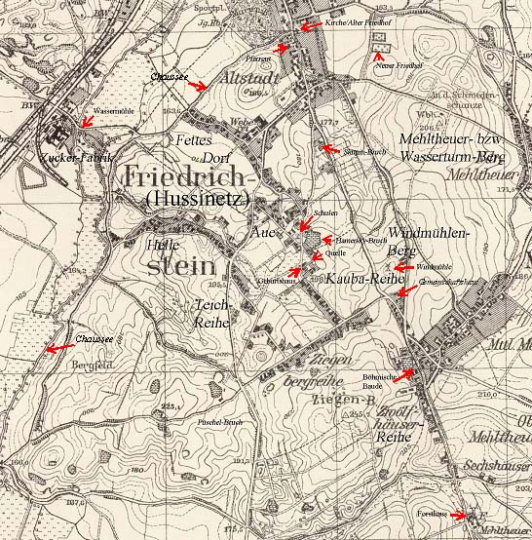

Figure 2: Extract of the Hussinetz corridor (including the southern part of the old town of Strehlen) from the Messtischblatt of 1884 with explanatory entries by the author, see arrows.
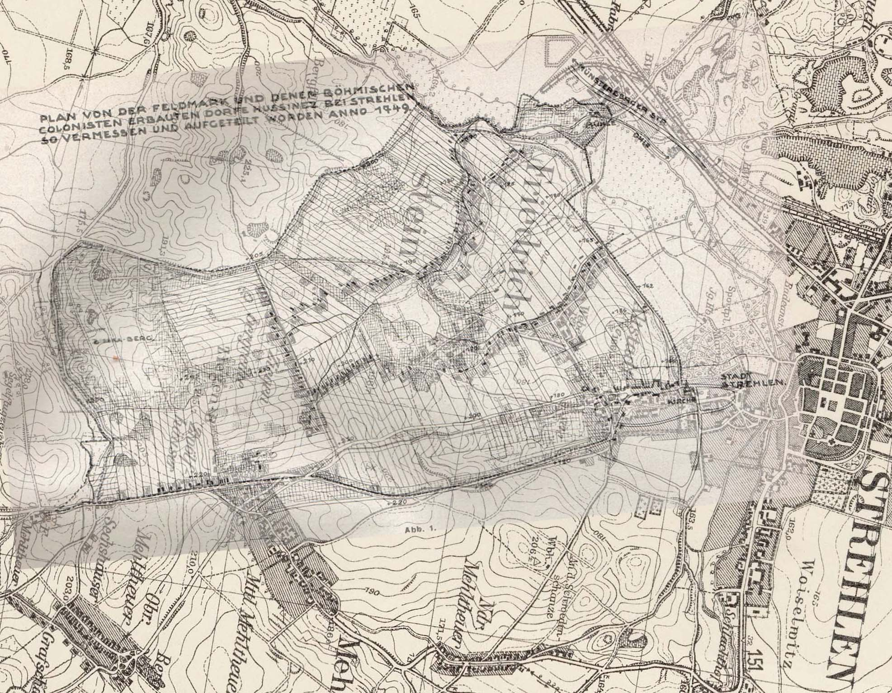

Figure 3: Superimposition of the Hussinetz plans to 1749 and 1884 (In the image processing, a slight shift of the reference lines was purposely set to facilitate the qualitative (!) Comparison.) It should be noted that in the area map (1749) flood plain the Corridor boundaries and that in the Messtischblatt (1884) instead, the contour lines are recorded.

Trocnov (about 1360-1424) was the most important military leader of the Hussites. He was next to Jan Hus (about 1369-1415, see naming the village!) Even in the 18th century as a symbol for the religious refugees, who also understood as a successor to the Bohemian brothers ¹³⁾. The mountain and its south "Ziegengrund" (Incidentally, even "Zisska reason") incidentally played in the older Strehlener history, eg in the Hussite Wars ¹⁴⁾ as well as in the Silesian Wars and in the Second World War an outstanding military role ¹⁵⁾.

The geographical center of the village is in the stock an initially broad valley, which tapers in the course northward. In the plan fall without special naming a large pond and other smaller on. These and other areas - the "Teichmorgen"/"Teichgärten" ¹⁶⁾ - with extensive meadows and remote land were always valuable areas of use, also for the Hussinetzer (fish farming, pasture). Already in the `Strehlischen Chronik` (1735) Johann Christof Brinke noted ¹⁷⁾:"There are also large ponds nearby, which provide the city with good and tasty fish. "A quotation from the purchase contract for 1749 according to note 1 is also: "The same with those belonging to the 4th Gardens, of which ... the fourth in the middle of the village lies also further with their associated meadows". Registered in the map are also the main streams with drain to the "Ohle" flow. Along the narrow valleys there are rows of pond cascades. (The stock also existing smaller ponds are not all marked!). These were partially created in the past with good yields, the so-called "Helderzins", partially artificial. This economically important pond landscape in Hussinetz has been preserved according to Figure 4 to modern times, although especially the water surfaces have been subjected to many changes, mostly in favor of land reclamation. It should also be noted that the ponds were initially not purchased item, but could be used only on a contractual basis, but what

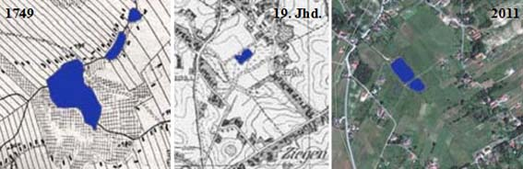

Figure 4: Development of the Hussinetzer pond landscape (scales only approximately comparable!, excerpt to 2011 from maps.google.de) the pugnacious Hussinetzer according to purchase contract from the beginning value, because there "like also the Fischerey"¹⁸⁾ was agreed.

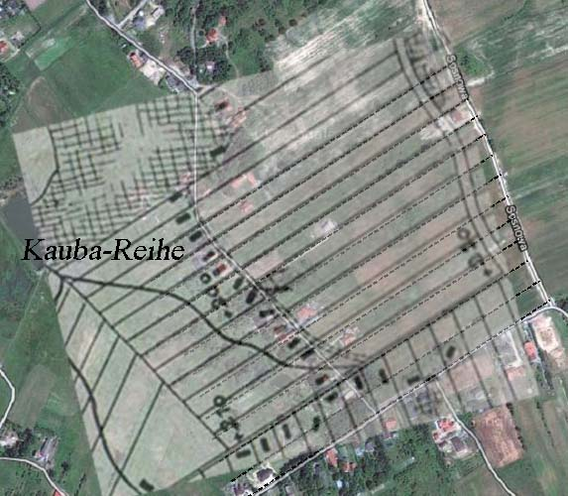

Figure 5: Projection of a field-corridor excerpt of the Kauba series from the map to 1749 on the corresponding area from maps.google.de: For better visibility, the parcel boundaries were traced dashed in the photo and also slightly distorted the site plan structure.
River / Grassland / Unland

All streams had great significance for Hussinetz. Thus, until the end of the Second World War, the numerous drinking water sources of the upcoming granitic soil were used for lack of other development. Although only two source locations are noted as starting points for streams in Figure 1, there was much more on the Hussinetzer floor. For example, the author's family (see "Birth House" in Figure 2) has traditionally used a source fountain (see "Source" in Figure 2). From there, a meadow stream not listed in the site plans has always fed the ponds in the middle of the figure. The large pond is marked with two drains, which is rather unusual in nature. Probably the lower drain was artificially created before 1749. Thus, the water supply of the settlement part "fat village" was now also as good guaranteed from 1749, as from Figure 2 for the settlement parts "Ziegenberg series", "Kauba series", "pond series" and "Helle" based on source locations or Brooks / ponds visible. Also, the "twelve-row" or the soon half "Bohemian" Old Town (purchase contract quote: "So buyers ... do not promise but a larger inflow of water, as such currently procure, ... to measure") were secured with natural drinking water resources, but were located above source locations on the "goat hill" - so had opened up in 1897 "twelve houses break" among other things, due to natural flooding in 1930 to be abandoned again ¹⁹⁾ - or "Mehltheuer- Berg ", the later so-called Strehlener" Wasserturm-Berg ", see Figure 2. The crystal clear Hussinetzer waters served until 1945 also fish and crabs and various populations of microbats as a habitat, which has been particularly appreciated in the biological literature of the 19th century is ²⁰⁾. Explicitly demanded the peasant village founders according to the purchase contract ("also with those ... meadows and Meadow Wax, near the Damm Mills ... also the Säu Ponds, the Mühlgraben above and under the Damm-Mühle ") an own watermill location, the woodworking for the house construction, see below, and certainly also the grain processing secure. Thus, the mapping of a mill construction (Mühlgraben, building) on ​​the right of the "Ohle" is understandable. The map of 1749 irritated insofar as the mill could not of course be located directly on the river, but was actually on the purpose-built Mühlgraben. The real local course of the "Ohle" marks the corridor border shifted to the north, compare Figure 2. In the 19th century, the sugar refinery was built on the left side of the Ohle River. At the time, Strehlen could do without worrying about this mill, because a Mühlgraben branched off to the north, see Figure 2, had been feeding the most important grain and fulling mill at the height of the former water gate since the Middle Ages. However, it is this confusion of river and Mühlgraben course as well as the still undivided or partially undivided Hussinetzer areas on the goat hill or in the area of the water mill further important evidence of authenticity. Such gross errors occur in older maps more often, but you can hardly imagine this in recent maps. While the corridor divisions in the area of the so-called "cattle pasture" began on Strehlens running waters already around 1713, those in the Hussinetzer time on the goat hill did not take place until 1852 and at the mill last around 1859 ²¹⁾.

Forest

South of Hussinetz, more precisely on the other side of the former "Obervorwerk", a large forest area expands in the Strehlener mountains. The quotation applies to 1544 ²²⁾, "the monastic forest extended to the Münsterberg Principality", which was already considered a town property around 1644 with the designation "Altstädter Wald". In the purchase contract to 1749 it is relevant in any case "with the Vorwerckern (Upper and Niedervorwerk) belonging grove and hüben the goat mountain called". It should be on the goat mountain thus around
Parts of the shrubbery fallen after the first period of the convent go, for in the "Concession" of Frederick the Great of June 24, 1750 to Hussinetz it is written ²³⁾: "but also the wood needed for their cultivation from the Strehlen and Priborn." and have them ordered by our Wroclaw Warden and Domainen Chamber for payment of the Schlager pay. ", and further ²⁴⁾:
"The settlers demanded free timber for 100 houses, the house calculated to be 20 tribes, i.e. 2,000 tribes. Incidentally, the Strehlener "Forsthaus" still exists as a cultural monument below the southernmost Hussinetzer Flurzipfels, see Figure 2. On the way there along the Zwölfhäuser-Reihe to the Rummelsberg - a famous place of pilgrimage ²⁵⁾ of various Silesian denominations and groups - nobody could overlook the most famous Hussinetzer hospitality, the "Bohemian Baude". It emerged at the end of the 19th century ²⁶⁾ from a settlement site already identified in the plan of 1749, see Figure 2.
The city of Strehlen - and soon next to the agriculture and weaving of the "Bohemian" villages ²⁷⁾ - brought the greatest wealth to the granite quarries, of which at least 8 are listed in the table sheet excerpt of 1884 according to Figure 2, and the good financial situation is expressed in the following quotation ²⁸⁾: "that Strehlen is one of the cities of Silesia having the lowest urban tax rates". In the map of 1749, however, there is no reference to such in the Hussinetzer corridor, although the quote from the purchase contract "those buyers überläßenen stone-Bruche" and information in the Goerlich Chronicle, according to which the quarry on the later Hussinetzflur already since the time existed around 1616 and supplied the city with stones, actually say everything ²⁹⁾. One can therefore only assume that it was in the old town to the then already long abandoned "Skupin break" on "Windmühlenberg" (both later names). Otherwise, numerous quarries have been developed in Hussinetz in the course of time according to Figure 2, but they had for natural, economic and / or ecological reasons always in favor of the huge Strehlen Granite Quarry, the "largest Europe" ³⁰⁾, are abandoned.

Watermill

In the church book of Hussinetz 31) becomes 1813 a Karel Schlechta (1727-1813), by occupation Müller, with the entry "1803 owner of estate No.101 (Mill) "mentioned. To what extent he - whose name does not appear in the available founders lists ³²⁾ - owner and operator of the 1749 in the site plan even with "mill" by name registered watermill was, despite the above numbering of the property cannot understand. In any case, it was part of the purchase inventory: "Also the sow pond, the mill race above and below the dam mill". In the older Strehlener language use was also "Thammühle" common ³³⁾. This mill with its buildings in stock has therefore been clearly taken over by the buyers in 1749, so that they could not be missing in the site plan.

Arable land

Although it is true, "because Strehlen has always been a corn-rich
country" ³⁴⁾. the former "collegiate property" was repeatedly discredited for mismanagement, for example around 1544 as a result of the Reformation ("Vorwerke neglected" ³⁵⁾) and ultimately in the middle of the 18th century, this condition led to the sale of the city of Strehlen and the founding of Hussinetz. From then on there was a jointly controlled, but individually operated management of unprecedented scale until the Second World War. The foundation of this success story was, in addition to the farming experience, the good quality of the granitic loess soil. Nevertheless, of course, the soil quality followed the considerable topographical height gradient within Hussinetz. This may explain the district name "Mastna Ves" ³⁶⁾ given by the "Bohemia" (see Figure 2 and Table 1) for the partial settlement at the transition to the particularly fertile Ohle flood plain.

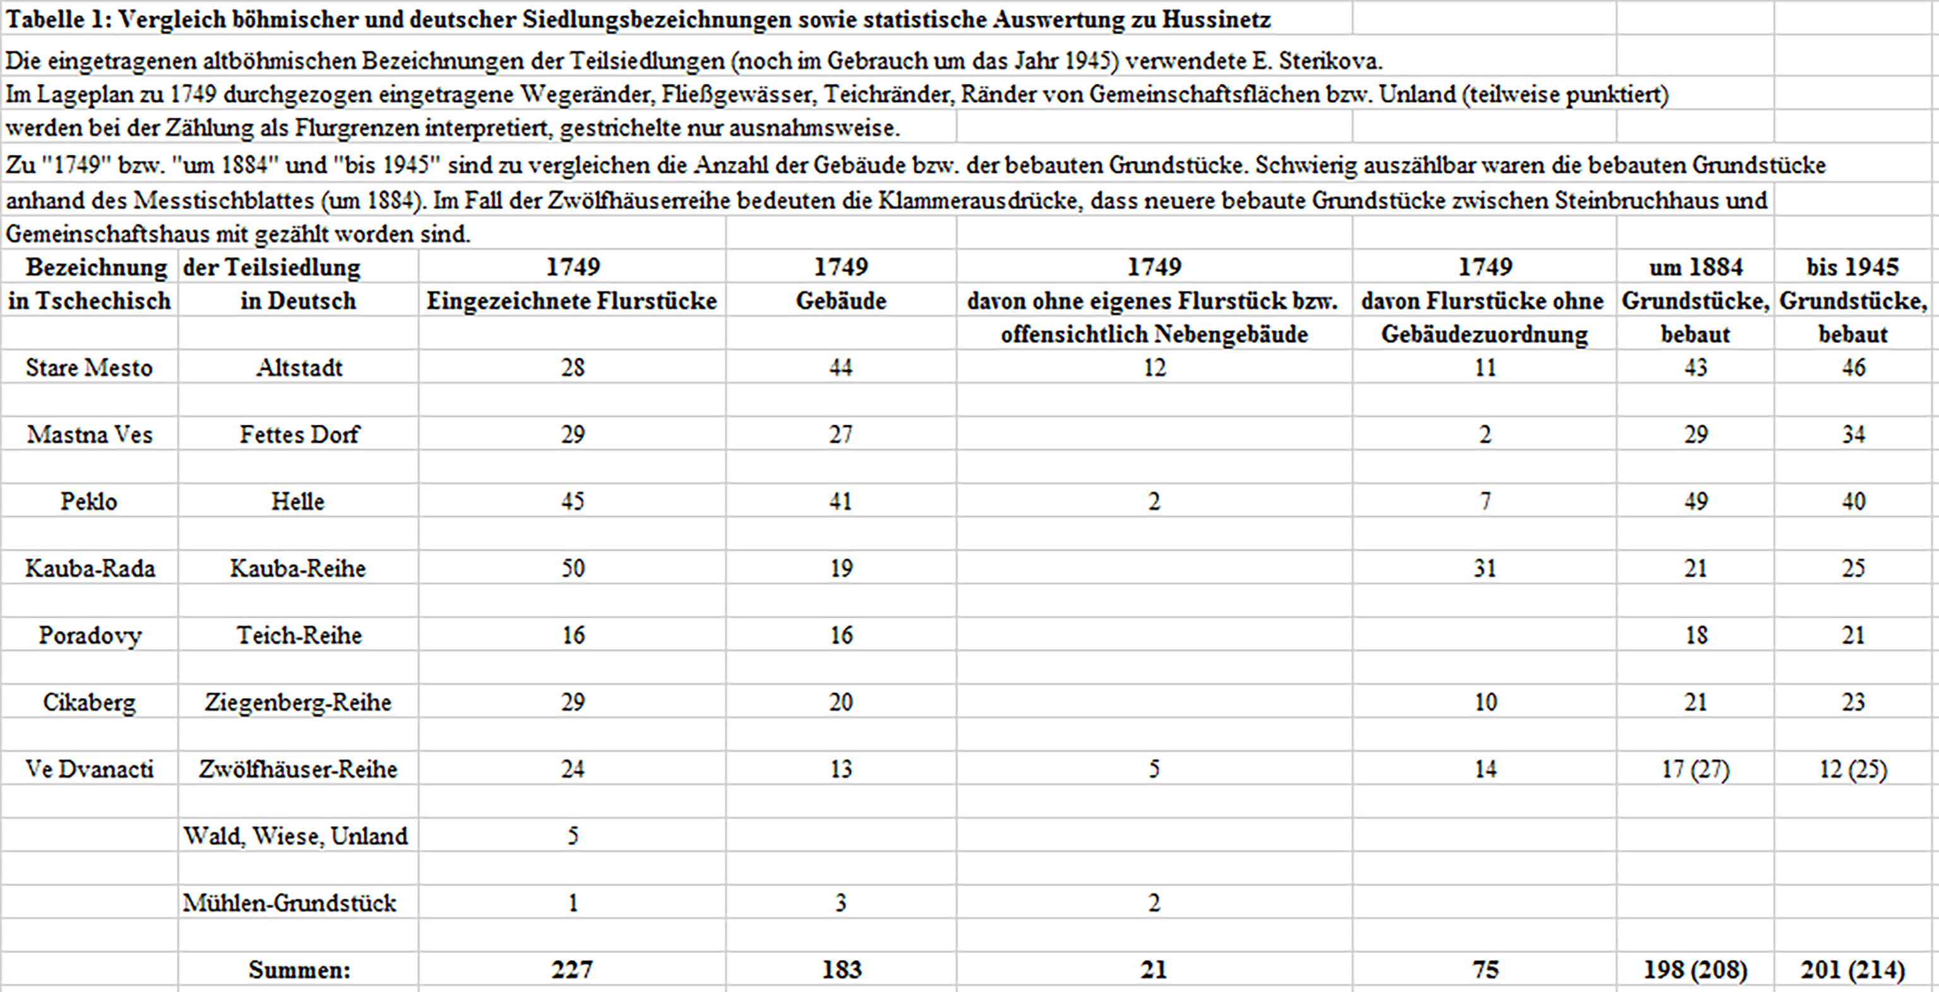

3. Settlement structure

If one compares, for example, with the German settlements of Saxony and Silesia in the 12th to 14th centuries, which in the rural area was essentially characterized by single-row forest village villages, then Hussinetz has a serious one Structure difference: One has to do with the planning and realization of a whole network of row settlements in one go. For the analysis (and for the surface monument protection!) The fact is significant that not - as otherwise customary in populous Germany usual - the old settlement structure over the years has been significantly overshadowed, but until today almost completely preserved. On the one hand, this is due to the once-simultaneous distribution of land to around 150 farming families - i.e. ten times the size of the medieval village foundations on so-called "wild roots" in Saxony ³⁷⁾ - which, of course, resulted in a lot of small parcels in Hussinetz, cf. Tab. 1. On the other hand, the special legal status granted by Frederick II and later also tolerated in Prussia for a long time ³⁸⁾ made the Hussinetzer community insignificant in this respect over the centuries. (An exception - and therefore at the same time again an important indication of the high age of the drawing content - is only the settlement area "Aue", see below, which does not exist in the map to 1749.) It is precisely for the Prussian-Bohemian Exulantenproblematik in Silesia, it is characteristic that the population growth that has occurred has always been overcome by new settlements outside the city, albeit mostly from Hussinetz. Thus, also those other "Bohemian" villages in the district of Strehlen, and the structure of Hussinetz remained largely untouched.

3.1 Object of purchase and designations in the settlement area

The Hussinetz founders - many of them as experienced farmers from the East Bohemian granary ³⁹⁾ came to Silesia near Königsgrätz - recognized their chance in the fertile soils already on the occasion of the first inspection of the object of purchase ⁴⁰⁾. Not only the two Vorwerke or the "Nieder-" and the "Obervorwerk" ⁴¹⁾ but also the southern old town with many other plots including the "church" St. Marien (built in 1130) ⁴²⁾ were added to the "Bohemia" according to the purchase contract and according to the present site plan. However, at first only the church and the "Old Cemetery" were directly incorporated into it by royal decree: "Fehrner gave their Majesty the same for their service in the old church, which was unmarried in the old city." ⁴³⁾
The first "Bohemian" service was celebrated on June 8, 1749 ⁴⁴⁾. The remainder, according to the contract of sale, provided for pre-emptive rights with private owners ("even the Acker pieces, ... as the Old Town gardeners ... want the same sothane Jus Protimisios (right of first refusal) to which the purchasers have transferred ") or to municipal property (" with houses of the Magistrats Jurisdiction to be purchased and located in the old town "). So also came this, often already built section of the map to Hussinetz. Today, among other things, on the basis of the symbolic cup-cross-architecture or the farmyards, see below, the well-formed by the "Bohemia" 172 years long and suburban shaped stock recognize well, because this part of the old town was after a first land consolidation (1921) was incorporated into Strehlen again in 1923 ⁴⁵⁾. In World War II, he also suffered the least loss of building substance in comparison to the other, massively destroyed areas in Strehlen and Hussinetz ⁴⁶⁾.

It is clear that the original Bohemian village name Husinec ⁴⁷⁾ also initially in the Old Czech language assigned names of the partial settlements belonged. Names in Czech and German are noted in Table 1.⁴⁸⁾ However, the Czech terms were soon used by the Hussinetzers also in German "translation", if only because the Prussian administrations in Strehlen and Wroclaw had demanded this from the outset, Only the name of the district "Helle" caused some difficulties. He clearly goes back to the "Helderzins" - fish tank (?), Pond holder (?) - back ⁴⁹⁾. Only the German and mythical imagination of descendants of the "Bohemia" made sure that at the time of the author even the completely misleading Name "hell" (Czech "Peklo") it has become. In this respect, Table 1 is not always the original, Old Czech name. Another example of the naming came about during the preliminary negotiations for the purchase agreement with reference to the coming spring ⁵⁰⁾: The settlers would then have to build a series of houses on the wide cattle route above Mehltheuer, where the place would be so large that they would also have smaller gardens "So probably the settlement" Twelve houses row "with the facts according to plan, that 8 farmers and 4 cottagers here took refuge, and the term "row" - rather than "street" in linguistic usage today - continued through: "Goat Mountain Range", "Pond Range". One even forgave the "series" in itself, but it later became the "Kauba series" with respect to one of their neighbors, see Figure 2. (In the author's time, it was said behind the scenes that the Kauba's are the richest of the Dorfes.) Only at the "Old Town" ("Stare Mesto") it remained, but in the "Bohemian" part underwent an unprecedented appreciation in all respects, and with the rapid economic development in the area "Aue" (workers in the quarry, in the sugar factory and in the Buntweberei as well as decoupling of Hussinetzer traders from urban conditions and restrictions) found the village structuring in the 19./20. Century culminating conclusion. Although no names have been entered in the map of 1749, the original partial settlements are already clearly visible on the basis of the layout of the land and the development. It lacks, as I said, only the "Aue" settlement, which is due to a certain subsequent overpopulation and especially the fact that in 19./20. In the 19th century, it was the strong group of workers and tradesmen who settled here. So one of the great-grandfathers got married and founded a carpentry estate in the "Aue". Remarkable for the "Hussinetzer community" - which saw its social "center" always in the church - is the absence of a city hall and thus an actual village center. Consistent with that, one cannot actually make one out of the site plan. Only in the 20th century took over the neighboring school buildings ("Old School" from 1830, "New School" from 1923) - on the Schulberg, so located at least in the geographical center - and decentralized on the Windmühlenberg built around 1926 "community house" more or less this role, see also Figure 2.

3.2 Corridor boundaries

In the site plan to 1749 immediately the close-meshed corridor division with the narrow field parcels on. A statistical comparison 1749/1945 can be found in Table 1, which i.a. expresses how the village structure has been conserved over the long term despite astonishing economic development. Heyman Ehrlich ⁵¹⁾ stated in 1868 with reference to the older sources as follows: "Finally, in 1752 the new village called Hussinetz was built, and on September 10, 1752, after a detailed census, there were 152 family fathers with a population of 549." Wenceslaus Blanitzky supplemented as early as 1749 ⁵²⁾: "Every family receives a piece of field from the 7th, 8th to 9th geometric mornings", which was only about 2 ha on average.

The outer boundary of the Hussinetzer Dorfflur is shown in the map with a dashed line almost closed. However, it is again an important indication of the authenticity of the presentation, that this just does not apply to the old town area, because in 1749 the incorporation was not completed by land purchase, see above ⁵³⁾. To the preservation of the narrow fields to the present to demonstrate time, in Figure 5 a section of the map of 1749 was compared with the corresponding section of maps.google.de. The dimensional agreement is amazing.

3.3 Number of posts

The parcel distribution to the emigrants was proven by lot - which is almost certainly unique in the founding history of European settlements - with subsequently limited, private barter ⁵⁴⁾. If one counts out according to Table 1 in the site plan, then the results for the year 1749 existing or planned partial settlements, including mill property, but without old town, a balance of approximately 190 field parcels, which are in good agreement to the number 152 of "family fathers" in the year 1749 with approximately 140 single buildings occupied. Part of the undeveloped parcels is probably to be understood as compensation and/or Vorhalteflächen. In addition, it should be noted that several families (eg the sexton) or individuals (e.g. the pastor W. Blanitzki), according to tradition, immediately found their way into the old city.⁵⁵⁾ With regard to the further development in Hussinetz, Slavik summarizes in the year 1870 as follows ⁵⁶⁾: To 1751 "As early as the second year, 155 resident families were counted (approx. 550 persons, see above). Of these families there were 27 widowed women. "And to 1870" On the whole, Hussinetz counts 188 buildings, of which 145 are agriculturists and 43 cottagers (at 1,300 persons!) ". If one takes this information literally, then this in turn is an authenticity indicator, because first of all 188 home owners are meant to 1870 already. Secondly, even adding up all 140 properties in the partial settlements and the maximum of about 30 old-town plots according to Table 1 would only amount to around 170 Neusiedler in 1749. Thus, it is rather impossible for the historical site plan to be a later one.

The high number of inhabitants in 1870 is due to the enormous increase in the number of children per family in the 19th century ⁵⁷⁾.

4. Location and type of buildings

The Mayor of Strehlen, Johann Ruths ⁵⁸⁾, who ruled from 1746 to 1775, showed the buyers at the first visit of the outworks "how they could build the houses for many families along the fields in such a way that they could open their fields in front of the door”.⁵⁹⁾ We do not know if the development actually took place according to its own ideas, but the site plan - apart from the piece in the settlement areas "Pond Row" and "Kauba Row" - makes it easy to see the assignment of the buildings to existing paths. Much later, in the inventory of 1945, all the houses and yards were located directly on well-developed roads or roads, without having to imagine relocated in the site plan to 1749 designated building sites. This is also apparent from Figure 2, where it is also evident that the development of course has been adapted to the natural conditions (valleys / rivers, remote / wetlands, elevations / slopes). This is even true even today for the on-site more heavily reformed Old Town area, but meant for the later added part of the settlement "Aue" some additional development measures. This particularly concerns the road, already dashed, in Fig. 1, later to the "Chaussee" developed road to the "Bohemian" colony Eichwald
(Figure 2). The map of 1749 also seems to be true to detail in the registered building plans. It is namely the building form and Bauplatzanordnung the then newly built or planned Einseithöfe or single building and a number of existing buildings or inventory ensembles (watermill, old city objects, see below) in good accordance with later documented finds ⁶⁰⁾ out of it. Much has been handed down about the construction of peasant new buildings.⁶¹⁾ The source quote "The settlers demanded free timber for 100 houses, the house calculated to be 20 tribes", and the Wroclaw government gave the advice, "with the building inspector Siegel in Strehlen to consider whether it will not be advisable to build massively, as the quarry stones are at hand”⁶²⁾. A very convincing argument for the authenticity of the map to 1749, at any rate, are the different distances and alignments of Einseithöfe (up to the floor plan deviations in rare individual cases) in the village districts relative to the corridor boundaries and paths. If it was a subsequent schematic model, the draftsman would certainly have attached importance to a uniformity in this regard, as is the case in the so-called "Jirman Plan"⁶³⁾ on Hussinetz 1945, for example.

It is largely agreed in the literature ⁶⁴⁾, that the photo no. 1 in
Figure 6 shows the true type of the first stone/wood-built, thatched Einseithöfe in Hussinetz. Although in the "Bohemian" villages at Strehlen, probably the very first buildings according to East Bohemian model ⁶⁵⁾ were actually made entirely in wood, because "the first residential and farm buildings were all built of wood and covered with straw"⁶⁶⁾ one will soon deviate from one's own demand and follow the instructions of Building Inspector Siegel, because there was a lack of documented objections to tree trunks in the royal forests.

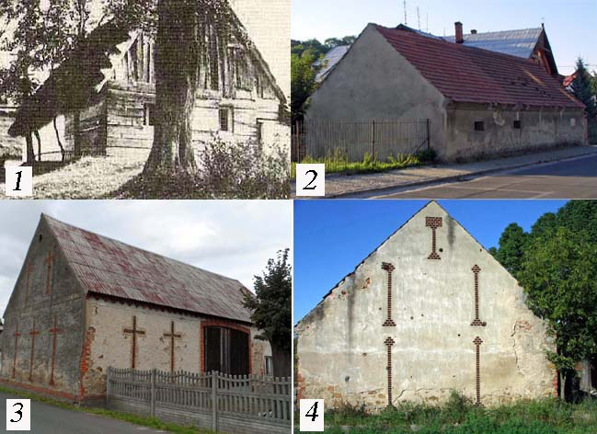

Figure 6: Distinctive monuments of the "Bohemian" culture in Hussinetz and in the old town of Strehlen: 1 Einseithof/Hussinetz from the early days, 2 outbuildings/Old Town, built before 1749, the later "Bohemian" parish estate, 3 cross architecture of a barrn/Hussinetz, 4 goblet architecture of a barn/Hussinetz

As already mentioned, in Hussinetz the number of jobs has been fixed at an astonishingly long time, namely until 1945. Apart from the inflow in the "Aue" settlement, the village structure persisted largely at the level of 1749. It should be noted the "occupation", see Messtischblatt in Figure 2, the first unallocated parcels in the "twelve-row houses", which therefore 1749 but probably the planned for the arrivals for newcomers served in the 18th century. Almost all other building accesses in the rural areas of Hussinetz - as well as the author's typical birthstone house - are, as already noted, due to the rapid growth of factory and quarry workers and traders in the 19th century. It should also be noted that only in this time a radical
Restructuring and the conversion and rebuilding of the farms took place, whereby the characteristic goblet cross architecture came up,⁶⁷⁾ see
Figure 6, which is rightly considered of great importance for the preservation of monuments. There are only a few noteworthy, unexplained substance excretions from the stock to 1749, so in the range of height 125 in the "bright" settlement, see Figures 1 and 2.

5. The Hussinetzer Old Town settlement

The old town occupies a special position in many respects. Already the explanation of the mayor Ruths in the purchase negotiations, it is in the old town a commercial takeover of indebted houses possible, also 26 abandoned posts could be rebuilt, is a corresponding inventory reference, which found its visible expression in the old site plan. The buildings dating back to 1749 actually give the number 26 at count of the parish-related building ensemble and separable houses without parcel delineation with low tolerance. However, you get in Figure 1 rather the impression of an already existing complete suburb. You can also see the church, the small "Küsterhaus" on the right next door and the group of buildings converted from the "Bohemia" to the "Pfarrhof" (see Figure 2) a little bit landward on the other side of the street. According to the purchase contract or its royal confirmation, it belonged to the "two building tracts, with four barns, stables, sheepfolds and the Schafferhaus" and was the administrative seat of the Untervorwerk.⁶⁸⁾ The last old-town court in the plan of the land could according to number of outbuildings as that second "building wing" belonged to the Obervorwerk. In any case, one counts in both objects or the associated parcels together nine buildings.

For example, the well preserved street side outbuilding of the parish, see Figure 6 (no. 2), has a very special meaning because of its very old age. The large parcels around the Marien Church also point to the former "Probstmorgen ... behind the Marienberg"⁶⁹⁾. Just as happened with the "monastery forest", in the middle of the 16th century, in the course of the Reformation, the transformation into the then ducal "Kammergut" took place as the Emperor's Lent in Vienna.

In the 17th century, the later Hussinetzer corridor was dissected mainly into several noble estates and other private possessions. According to Franz Xaver Goerlich, there were already "34 owners" in the entire Old Town around 1616, but in 1622 only "8 farmers and 19 gardeners".⁷⁰⁾ It must be noted that in the map to 1749 so only the part of the old town is recorded, which later came to Hussinetz. However, one can imagine especially in this area the peasant or horticultural land, especially as the sum 27 of the farmers and gardeners surprisingly correlated with the number of 26 places mentioned by Mayor Ruths and in the map to 1749 according to Table 1 a total of 28 identifiable parcels recorded are. However, the council of the city did not buy the outworks from the Lords of Brauchitsch until around 1713,⁷¹⁾ and subsequently - as in the case of the "cattle pasture" - a further parcelling and privatization should have taken place.

Literature
1) Bernd Radetzki: At home in Hussinetz, Friedrichstein, Gesiniec, Preussler-Verlag, Nuremberg 2012: The purchase agreement dated April 30, 1749, the concession of June 24, 1750 (see pages 31 to 36 and p. 37 / 38 and pages 348 to 351).
2) Radetzki (see note 1), pp. 28 and 30
3) Johann Jakob Simmler's Collection (1716-1788), Manuscript Department of the Central Library of Zurich, identification "Ms S 255 to Ms S 376" (Letter as a film copy on pp. 31 to 33, published in www.ditmar-kuehne.de/pdf/ BriefeZH.pdf)
4) Bruno Klebs: The founding of ev.-ref. Municipality of Hussinetz by Frederick the Great, Strehlener Heimatbuch, Volume 3, Strehlen 1927 (published in http://petertscherny.pe.funpic.de/strehlen/hussinetz/klebs1927.pdf, here p. 5)
5) Plan of the city of Dresden from 1750 to Lynar, published in de.wikipedia.org/wiki/Zwinger_(Dresden)
6) Hans-Dieter Langer: The treasure chambers of treasure chambers, Rhombos-Verlag, Berlin 2002, p. 132; see also in the documentary of the author: "If stones could speak-undiscovered Chemnitz", on DVD, Chemnitz 2010
7) Schroettersche Landesaufnahme (1796 to 1802) with map examples, published in de.wikipedia.org/wiki/Schroettersche_Landesaufnahme
8) Klebs (as note 4), p. 2
9) Note: The deliberate slight final shift in Figure 2 allows you to better contrast landscape and settlement details.
10) Hans-Dieter Langer: Evaluation Report for the 3rd International Culture Conference Hussinetz / Strehlen, 19 to 21 October 2012, Frankenberg / Sa. (published in www.drhdl.de/pdfs/2012_Bericht.pdf)
11) Hans-Dieter Langer: Pre-publications from a book by the author about his Silesian hometown Hussinetz / Friedrichstein / Gesiniec (here "A small earth and natural history of the" Strehlen / Hussinetzer Scholle "in www.drhdl.de/Scholle.html)
12) Letter of 17.6.1748 in the context of the preliminary negotiations for the purchase of mayor Ruths to the "Wroclaw Government", quoted by Klebs (as note 4), p. 2
13) Langer (like note 11), here "still 300 years to Hussinetz", see www.drhdl.de/pdfs/300JahrebisHussinetz3.pdf
14) Note: Scattering was e.g. during the Hussite wars always threatened and attacked from the extensive forest area south of the goat mountain ago.
15) Langer (as note 11), here (1) "Frederick the Great from Hussinetzer and Strehlener perspective" in www.drhdl.de/pdfs/Friedrich_d_G.pdf, see in the texts under the pictures 03 and 07, and ( 2) "The War in Hussinetz" in www.drhdl.de/pdfs/Krieg_in_Hussinetz.pdf, see in the section "The situation of the Wehrmacht in Hussinetz"
16) Franz Xaver Goerlich: History of the City Strehlen in Prussian-Silesia, Wroclaw 1853, p. 171
17) Johann Christof Brinke: Strehlische Chronika from 1735 (edited, expanded and published with the subtitle "Chronicle of the Middle Silesian county town Strehlen from 1250 to 1741" by Josef Alfred Hoffmann, printing and publishing Paul Neumann, Velen in Westphalia 1962), S.4
18) Radetzki (see note 1), p. 33
19) Langer (as note 11), here "The tragedy and the blessing of Paul Hanusch and the historic Hussinetzer wedding" in www.drhdl.de/Hanusch.html, see in the section "On Sunday before the wedding in Hussinetz"
20) Gottlob Ludwig Rabenhorst: The algae of Europe, Decades I-CTX, numbers 1-1600, Dresden (1861-1882); see also in www.huh.harvard.edu/diatom/rabenhorstalgeur.htm under the keyword "Hussinetz" and in Langer (as note 11), here "Hänschen and the small animals" in www.drhdl.de/61HaenschenTiere.html
21) Notes: The authors Hans-Dieter Langer and Falk-Uwe Langer of the study in progress "Historical mills in Frankenberg / Sa." Is a case in a similar context to Frankenberg/Sa. known from 1614. The Strehlener parcellations of the "cattle pasture" and the corridor divisions at Ziegenberg and at the mill are documented in Goerlich (as note 16), p. 518, or the unknown author of the chronicle of the community Hussinetz (Friedrichstein), the period 1749-18 Concerning 1907, published by Ditmar Kühne in
ditmar-kuehne.de/pdf/Chronik.pdf.
22) Goerlich (see note 16), p. 170
23) Heyman Ehrlich: Culture and founding history of the five Bohemian colonies at Strehlen (Original version 1868, reprinted in Strehlener Heimatblatt in the years 1999 to 2000, published on the Internet at petertscherny.pe.funpic.de/strehlen/hussinetz/chronik-ehrlich1868. pdf, here p. 1-12)
24) Klebs (see note 4), here p. 4
25) Ulrich Bunzel: The community festival on the Rummelsberge (published in http://freepages.genealogy.rootsweb.ancestry.com/~bgwiehle/schlesien/kirchen/
festschr1.htm # Community proof)
26) Josef Alfred Hoffmann (editor and publisher): Strehlener city and Kreisgeschichten 1741-1945, printing and publishing house Paul Neumann, Velen in Westphalia 1962, part 3, Strehlens ascent and descent 1901-1932, S. 8
27) Radetzki (see note 2), pp. 88-95
28) Hoffmann (see note 26), p. 16
29) Goerlich (see note 16), p. 327
30) Langer (like note 11)
31) Note: The church books of Hussinetz are completely online at www.online-ofb.de/hussinetz.
32) Hans-Dieter Langer: Founder of the village Hussinetz / Silesia in 1749, published in www.drhdl.de/fotos_hussin/Hussinetzgruender.xls); Radetzki (see Note 1), here in Section III "First settler in Hussinetz", p. 39 to 46
33) In use were the name "Dammühle also after Ehrlich (as note 23), p. 3, while "Thammühle” stands with Görlich (as note 16), p. 323
34) Goerlich (see note 16), p. 149
35) Goerlich (see note 16), p. 171 and 175/76
36) in German: "fat village"
37) Langer (as note 6), p.7
38) Ludwig Waldecker: Hussinetz - A Contribution to the History of Prussian Administrative Law, in: Treatises of the Silesian Society for Patriotic Culture, Humanities Series, Issue 5, Wroclaw (1931), pp. 144-179
39) Peter Englund: The Devastation of Germany - A History of the Thirty Years' War, Klett-Cotta, Stuttgart 1998, p. 208
40) Wenzeslaus Blanitzky: History of the Hussites established in Silesia, unpublished manuscript, Königsberg (1763), edited by Ditmar Kuehne, Books on Demand GmbH, Kulmbach 2001, p. 280
41) Goerlich (see note 16), p. 324
42) Vladimir Mican: Ve Vyhnanstvi (In Emigration), after a manuscript from 1924, edited by J. Simek, Naklad Biblicke Jednoty, Brno 1927, p. 94; Note: Brinkes (as note 17) formulated as follows: "founded after 1150")
43) Letter from Pastor W. Blanitzky dated June 25, 1749, to his friend and theologian Johann Jakob Simmler in Switzerland (see Note 3), letter as a film copy on p. 29
44) Unknown author (as note 21), p. 1
45) Hoffmann (see note 26), p. 34
46) Langer (see note 15), here at (2)
47) Radetzki (see note 1) p. 62/63
48) In Table 1, the Czech names of the partial settlements are noted as the author experienced in his Silesian period (1941-1950).
49) Goerlich (see note 16), p. 171
50) Klebs (as note 4, here p. 1): Quotation from a letter of 17 June 1948 of the Strehlener mayor Ruths to the responsible Wroclaw government
51) Honest (as in note 23), p. 4
52) Radetzki (as note 1), p. 64, note: It is quoted from a letter from W. Blanitzky of December 13, 1749 to the Basel University Professor Beck.
53) Note: Among other things, the so-called "New Cemetery" was created in 1909 below the path marked on the bottom right, see Figure 2.
54) Radetzki (see note 2), pp. 97 to 114
55) Langer (like note 11), here "The Utikal-Küster von Hussinetz", see www.drhdl.de/Utikal.html; Edita Sterikova: Exulantsky Kazatel (Exuberant Pastor), KALICH Publishers, Praha 2007, p. 295
56) Frantisek Augustin Slavik: Potomci Bratri ceskych v Pruskem Slezsku (descendants of the Bohemian brothers in Prussia Silesia), Svetozor, 4th generation, Prague 1870, pp. 21-22 and 26-27
57) Ditmar Kühne: The church books and other historical sources of Husinec-Hussinetz, lecture at the 1st International Conference Hussinetz/Strehlen, Strzelin 2008, published in http://ditmar-kuehne.de/pdf/Vortrag.pdf, here S 14/15
58) Goerlich (see note 16), p. 585
59) Bruno Klebs (see note 4), p. 2
60) Radetzki (see note 1), pp. 64-66; Langer (like note 10)
61) Radetzki (see note 1) pp. 67-69
62) Klebs (see note 4), p. 4
63) Langer (like note 11), here "Jirman-Plan" in www.drhdl.de/fotos_hussin/JirmanPlan2.jpg; Hans-Dieter Langer: Husinec-Hussinetz-Friedrichstein Gesiniec in the course of time - Reason enough for a European project for the future ?, Lecture at the 1st International Conference Hussinetz/Strehlen, Strzelin 2008, published in www.drhdl.de/pdfs/Vortrag .pdf)
64) Edita Sterikova: Z nouze o spaseni, Ceska emigrace v 18. Stoleti do pruskeho Slezska (Saved from poverty - Czech emigration in the 18th century in Prussian Silesia), Evangelicke nakladatelstvi Kalich, Praha 1992, picture 90; Radetzki (see note 61); Langer (like note 11), here "The Cultural Island Strehlen/Hussinetz-Strzelin / Gesiniec-Strelin / Husinec in Pictures and Views" in www.drhdl.de/pdfs/Diavortrag.pdf
65) Sterikova (as in note 64), in particular image 189 in comparison to image 90
66) Johann Traugott Krinis, Friedrich Czech, Gottlieb Schicha, Josef Zwikirsch, Gerhard Matzel, Erich Rosemann: School chronicle of the school in Central-Podiebrad (first book: 1836 to 1935), manuscript in manuscript, edited by Peter Tscherny, published in petertscherny.pe .funpic.de / strassen / podiebrad / chronp.pdf, here p. 48
67) Langer (like note 10)
68) Sterikova (see note 64), here in particular picture 85; Karl Barta: Reminiscences 2010: K. Barta translated numerous written in the Old Bohemian scriptures into German - see also Radetzki (as note 1) - as well as the 1750 by the Hussinetzer "Bohemia" translated into their language "Gracious Decret" Frederick of great. He made part of these translations available to the author in 2010 as typewritten text. (Hint: One reads in the "Gnadiges Decret" on the one hand of "a school in the churchyard." On the other hand, there is also talk of a "standing on this property house of the gravediggers." In any case, lived there from 1805 at the latest the sexton, see Langer (like note 55).
69) Goerlich (see note 16), p. 322
70) Goerlich (see note 16) p. 321 and 326, respectively
71) Goerlich (see note 16), p. 518
72) Eduard Winter: The Czech and Slovak Emigration to Germany in the 17th and 18th Centuries, Akademie-Verlag, Berlin 1955, pp. 158-163
73) Hugo Weczerka (ed.): Handbook of Historical Sites Silesia, Alfred Kröner Verlag, Stuttgart 2003, p. 203
74) Commentary on Weczerka (see note 73) in http://en.wikipedia.org/wiki/manual_historical_sites
75) Extract from the product description to Weczerka (see note 73) in http://www.buecher.de/shop/buecher/handbuch-der-historischen-staetten-schlesien/weczerka-hugo-hrsg-/products_products/detail/ prod_id / 01248904 /

